TRIAL BY JURY

AN OPERETTA

SCENE – A Court of Law at Westminster

Opening Chorus of Counsel, Attorneys, and Populace.

Hark! The hour of ten is sounding,
Hearts with anxious hopes are bounding,
Halls of Justice crowds surrounding,
Breathing hope and fear –
For to-day in this arena
Summoned by a stern subpoena
EDWIN sued by ANGELINA,
Shortly will appear!

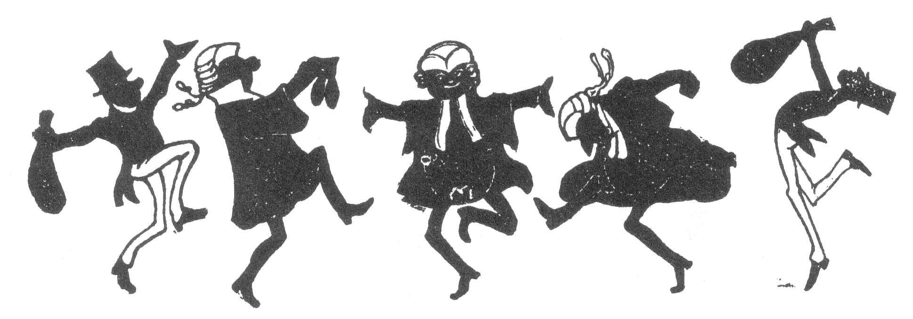

Chorus of Attorneys.

Attorneys are we
And we pocket our fee,
Singing so merrily, “Trial la law!”
With our merry ca. sa.,
And our jolly fi. fa.
Worshipping verily Trial la law!
Trial la law!
Trial la law!
Worshipping verily Trial la law!

Chorus of Barristers.

Barristers we,
With demurrer and plea,
Singing so merrily, “Trial la law!”
Be-wigged and be-gowned
We rejoice at the sound
Of the several syllables “Trial by law”
Trial la law!
Trial la law!
Singing so merrily, “Trial la law!”

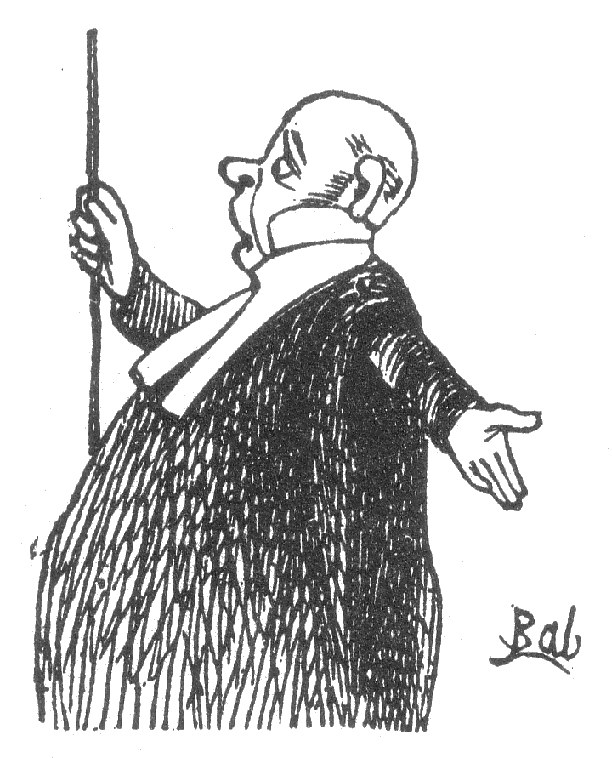
Usher. – Silence in court, and all attention lend!
Behold the Judge! In due submission bend.

(The Judge enters and bows to the Bar.
The Bar returns the compliment.)

Recitative.

Counsel for the Plaintiff. – May it please you, my lud!
Gentlemen of the Jury!

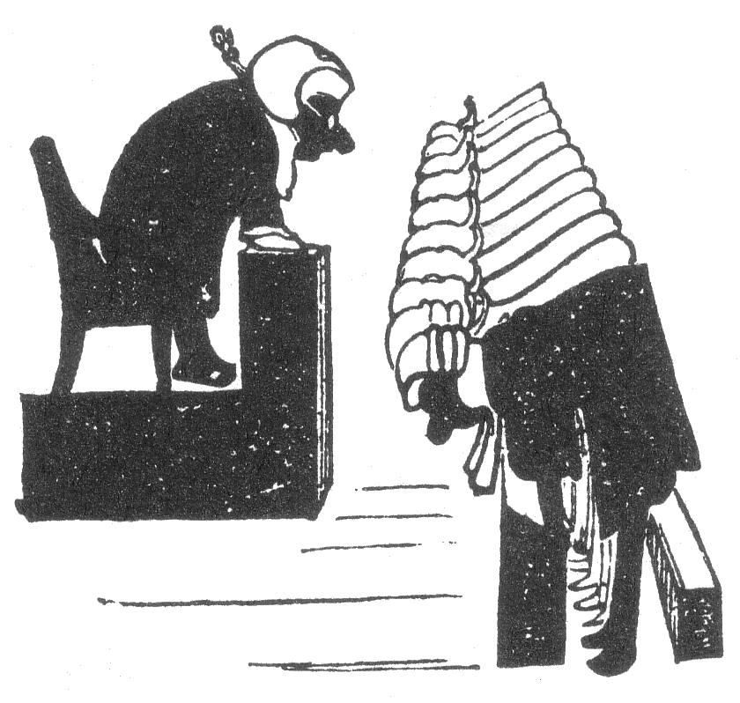
Aria.

With a sense of deep emotion
I approach this painful case,
For I never had a notion
That a man could be so base.
Or deceive a girl confiding,
Vows, et caetera, deriding!

All. –He deceived a girl confiding
Vows, et caetera, deriding!

Counsel. –See my interesting client,
Victim of a heartless wile,
See the traitor all defiant
Wear a supercilious smile:
Sweetly smiled my client on him,
Coyly woo’d and gently won him!

All. – Sweetly smiled the plaintiff on him,
Coyly woo’d and gently won him!

Counsel. – Swifltly sped each honied hour
Spent with this unmanly male,
Camberwell became a bower,
Peckham an Arcadian vale;
Breathing concentrated otto!
An existence á la Watteau!

All. – Bless us, concentrated otto!
An existence á la Watteau!

Counsel. – Picture, then, my client naming
And insisting on the day,
Picture him excuses framing,
Going from her far away,
Doubly criminal to do so
For the maid had bought her trousseau!

All. – Doubly criminal to do so
For the maid had bought her trousseau!

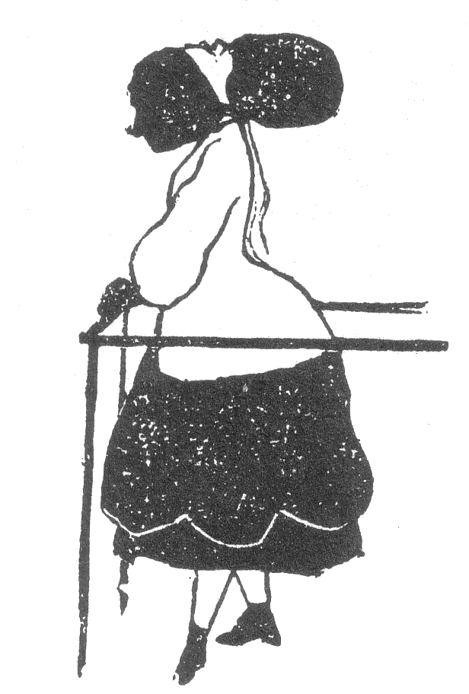
Recitative.

Counsel. – ANGELINA!

(ANGELINA steps into the witness box)

Solo.

Judge. – In the course of my career
As a Judex, sitting here,
Never, never, I declare,
Have I seen a maid so fair!

All. – Ah! Sly dog!

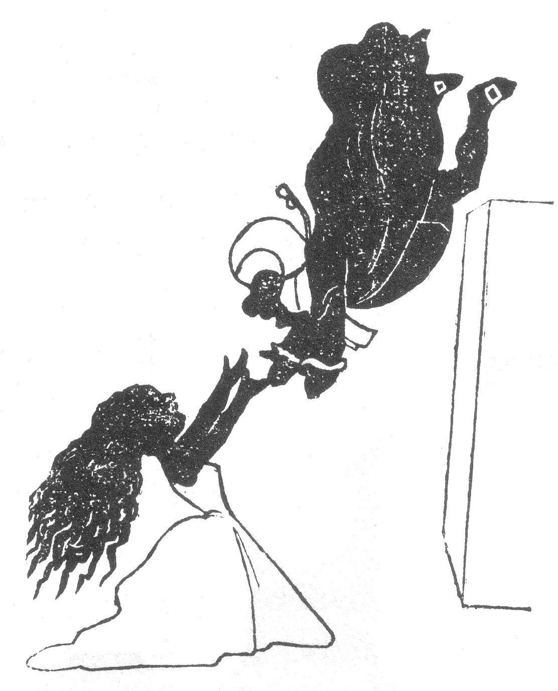
Judge. – See her sinking on her knees
In the Court of Common Pleas –
Place your briefs upon the shelf
I will marry her myself!

(He throws himself into her arms.)

All. – Ah! Sly dog!

Recitative.

Judge. – Come all of you – the breakfast I’ll prepare –
Five hundred and eleven, Eaton Square!

Final Chorus.

Trial la law! Trial la law!
Singing so merrily, Trial la law!

CURTAIN.

Published in Fun. Vol. VII - 11th April 1868

