A DISCONTENTED SUGAR BROKER
by W. S. Gilbert

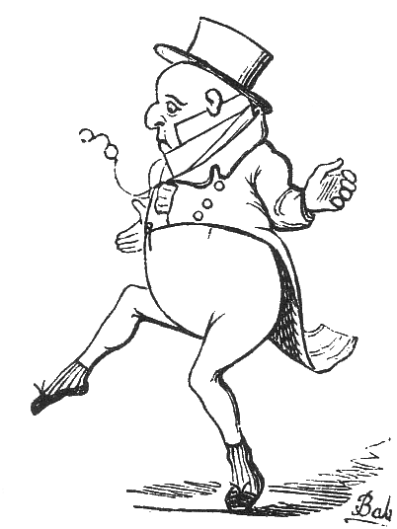

A Gentleman of City fame
Now claims your kind attention;
West India broking was his game,
His name I shall not mention;
No one of finely pointed sense
Would violate a confidence,
And shall I go
And do it? No.
His name I shall not mention.

He had a trusty wife and true,
And very cosy quarters,
A manager, a boy or two,
Six clerks, and seven porters.
A broker must be doing well
(As any lunatic can tell)
Who can employ
An active boy,
Six clerks, and seven porters.

His knocker advertised no dun,
No losses made him sulky,
He had one sorrow--only one--
He was extremely bulky.
A man must be, I beg to state,
Exceptionally fortunate
Who owns his chief
And only grief
Is being very bulky.
"This load," he'd say, "I cannot bear,
I'm nineteen stone or twenty!
Henceforward I'll go in for air
And exercise in plenty."
Most people think that, should it come,
They can reduce a bulging tum
To measures fair
By taking air
And exercise in plenty.

In every weather, every day,
Dry, muddy, wet, or gritty,
He took to dancing all the way
From Brompton to the City.
You do not often get the chance
Of seeing sugar-brokers dance
From their abode
In Fulham Road
Through Brompton to the City.

He braved the gay and guileless laugh
Of children with their nusses,
The loud uneducated chaff
Of clerks on omnibuses.
Against all minor things that rack
A nicely balanced mind, I'll back
The noisy chaff
And ill-bred laugh
Of clerks on omnibuses.

His friends, who heard his money chink,
And saw the house he rented,
And knew his wife, could never think
What made him discontented.
It never struck their simple minds
That fads are of eccentric kinds,
Nor would they own
That fat alone
Could make one discontented.

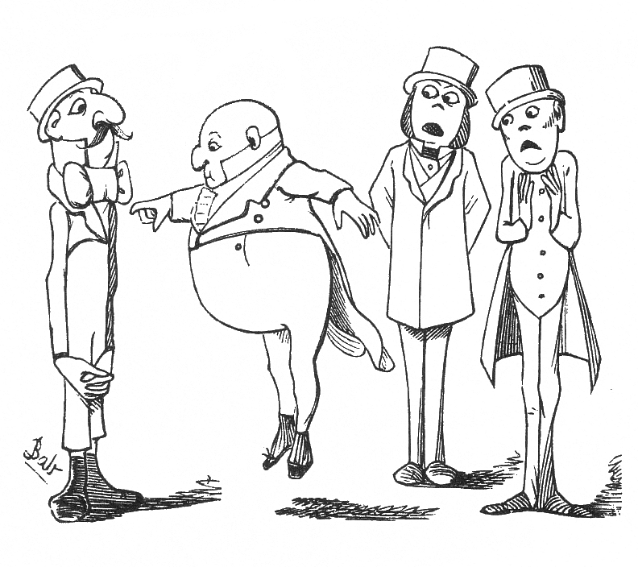
"Your riches know no kind of pause,
Your trade is fast advancing,
You dance--but not for joy, because
You weep as you are dancing.
To dance implies that man is glad,
To weep implies that man is sad.
But here are you
Who do the two--
You weep as you are dancing!

His mania soon got noised about
And into all the papers--
His size increased beyond a doubt
For all his reckless capers:
It may seem singular to you,
But all his friends admit it true--
The more he found
His figure round,
The more he cut his capers.

His bulk increased--no matter that--
He tried the more to toss it--
He never spoke of it as "fat"
But "adipose deposit."
Upon my word, it seems to me
Unpardonable vanity
(And worse than that)
To call your fat
An "adipose deposit."

At length his brawny knees gave way,
And on the carpet sinking,
Upon his shapeless back he lay
And kicked away like winking.
Instead of seeing in his state
The finger of unswerving Fate,
He laboured still
To work his will,
And kicked away like winking.

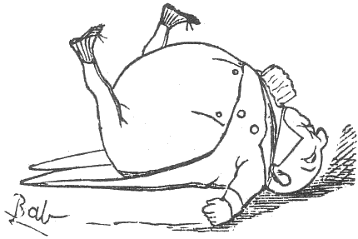

His friends, disgusted with him now
Away in silence wended--
I hardly like to tell you how
This dreadful story ended.
The shocking sequel to impart,
I must employ the limner's art--
If you would know,
This sketch will show
How his exertions ended.

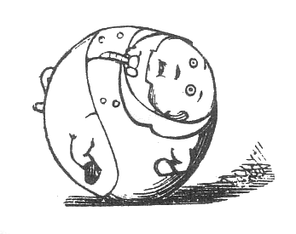

MORAL

I hate to preach--I hate to prate--
I'm no fanatic croaker,
But learn contentment from the fate
Of this West India broker.
He'd everything a man of taste
Could ever want, except a waist:
And discontent
His size anent,
And bootless perseverance blind
Completely wrecked the peace of mind
Of this West India broker.

Published in Fun 14 December 1867

