Gentle Alice Brown

by

W. S. Gilbert
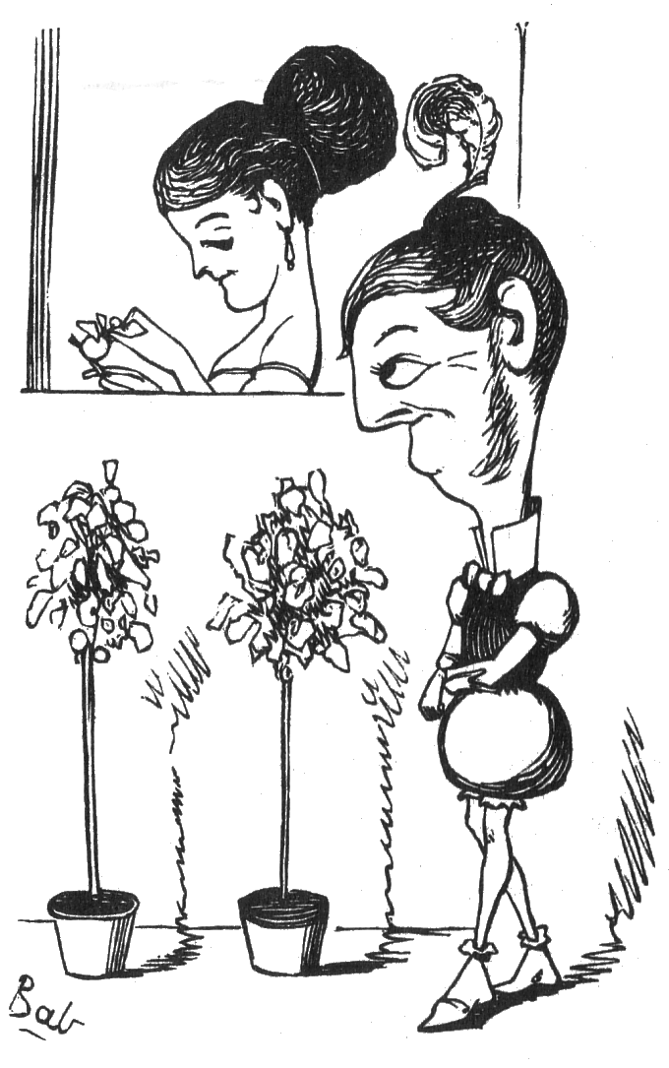

It was a robber’s daughter, and her name was Alice Brown.
Her father was the terror of a small Italian town;
Her mother was a foolish, weak, but amiable old thing;
But it isn’t of her parents that I’m going for to sing.

As Alice was a-sitting at her window-sill one day,
A beautiful young gentleman he chanced to pass that way;
She cast her eyes upon him, and he looked so good and true,
That she thought, “I could be happy with a gentleman like you!”

And every morning passed her house that cream of gentlemen,
She knew she might expect him at a quarter unto ten,
A sorter in the Custom-house, it was his daily road
(The Custom-house was fifteen minutes’ walk from her abode).

But Alice was a pious girl, who knew it wasn’t wise
To look at strange young sorters with expressive purple eyes;
So she sought the village priest to whom her family confessed,
The priest by whom their little sins were carefully assessed.

“Oh, holy father,” Alice said, “’t would grieve you, would it not?
To discover that I was a most disreputable lot!
Of all unhappy sinners I’m the most unhappy one!”
The padre said, “Whatever have you been and gone and done?”

I’ve helped mamma to steal a little kiddy from its dad,
I’ve assisted dear papa in cutting up a little lad.
I’ve planned a little burglary and forged a little check,
And slain a little baby for the coral on its neck!”

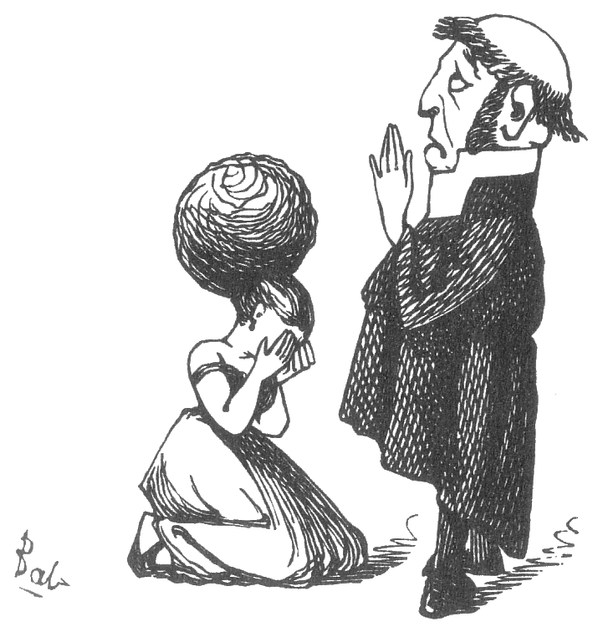
The worthy pastor heaved a sigh, and dropped a silent tear –
And said, “You mustn’t judge yourself too heavily, my dear –
It’s wrong to murder babies, little corals for to fleece;
But sins like these one expiates at half-a-crown apiece.

“Girls will be girls – you’re very young, and flighty in your mind;
Old heads upon young shoulders we must not expect to find:
We mustn’t be too hard upon these little girlish tricks –
Let’s see – five crimes at half-a-crown exactly twelve-and-six.”

“Oh, father,” little Alice cried, “your kindness makes me weep,
You do these little things for me so singularly cheap –
Your thoughtful liberality I never can forget;
But O there is another crime I haven’t mentioned yet!

“A pleasant-looking gentleman, with pretty purple eyes,
I’ve noticed at my window, as I’ve sat a-catching flies;
He passes by it every day as certain as can be –
I blush to say I’ve winked at him and he has winked at me!”

“For shame,” said Father Paul, “my erring daughter! On my word
This is the most distressing news that I have ever heard.
Why, naughty girl, your excellent papa has pledged your hand
To a promising young robber, the lieutenant of his band!

“This dreadful piece of news will pain your worthy parents so!
They are the most remunerative customers I know;
For many many years they’ve kept starvation from my doors,
I never knew so criminal a family as yours!

“The common country folk in this insipid neighbourhood
Have nothing to confess, they’re so ridiculously good;
And if you marry anyone respectable at all,
Why, you’ll reform, and what will then become of Father Paul?”

The worthy priest, he up and drew his cowl upon his crown,
And started off in haste to tell the news to Robber Brown;
To tell him how his daughter, who was now for marriage fit,
Had winked upon a sorter, who reciprocated it.

Good Robber Brown, he muffled up his anger pretty well,
He said, “I have a notion, and that notion I will tell;
I will nab this gay young sorter, terrify him into fits,
And get my gentle wife to chop him into little bits.

“I’ve studied Human Nature, and I know a thing or two,
Though a girl may fondly love a living gent, as many do –
A feeling of disgust upon her senses there will fall
When she looks upon his body chopped particularly small.”

He traced that gallant sorter to a still suburban square;
He watched his opportunity and seized him unaware;
He took a life-preserver and he hit him on the head,
And Mrs. Brown dissected him before she went to bed.

And pretty little Alice grew more settled in her mind,
She nevermore was guilty of a weakness of the kind,
Until at length good Robber Brown bestowed her pretty hand
On the promising young robber, the lieutenant of his band.

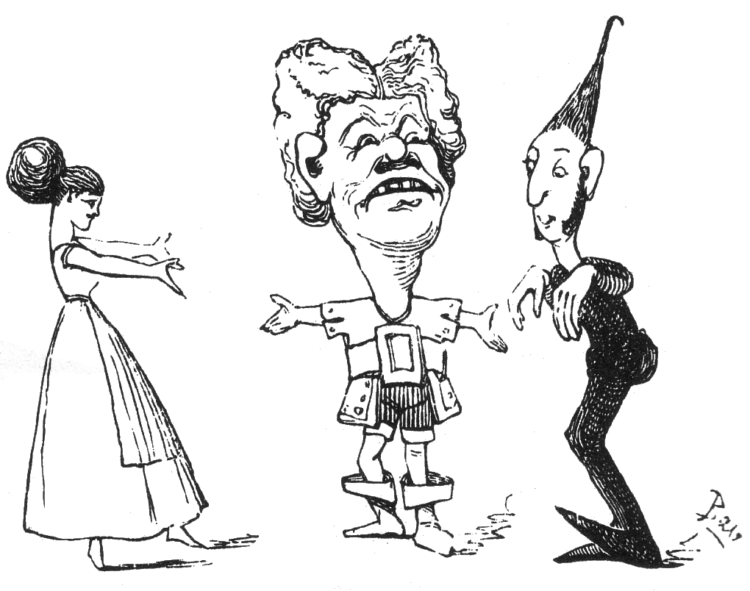

Fun, VII, 23 May 1868

